Social Science
Etoys School Map
Second - Third Grade Levels

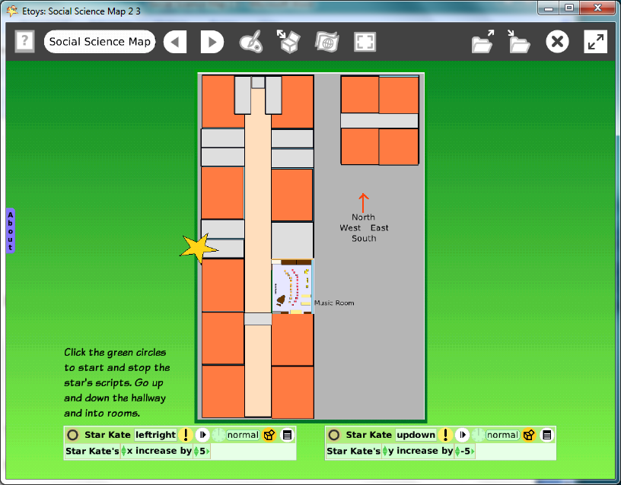

Introduction: | These two Etoys projects give students practice observing their classroom, a familiar place, in a larger map of their school. They analyze 3D shapes, distances, and how to represent them with 2D geometric shapes.  The map is then used in the second lesson as a place where an avatar moves to locations in the school.
Topic: | Creating maps of familiar places.
Subject: | Social Sciences
Time: | Lesson 1: 60 minutes  Lesson 2: 30 minutes
Description: | This project gives students practice observing 3D objects like rooms and playgrounds and representing them with 2D shapes.  Students explore the limits of map making.  Can we really show everything exactly when we make maps?
Vocabulary: | above, top, right, upper, center, on, up, beside, behind, below, bottom, left, lower, edge, near, down, before, between,  larger, smaller, close, near, next to, far, almost, same, forward, turn, x axis, y axis, rectangle, curve, triangle, ellipse, bigger, smaller, almost, exactly, North, South, East, West
Evaluation Criteria: | Recognizes classrooms and furnishings can be represented by 2D shapes on an Etoys map.  Shows the difference in proportions of a room and a building.  Shows a sense of the whole building’s space and proportions.  Uses a vocabulary of location fluently.  Knows which side of their school faces North.  Moves an avatar (a star) to different locations on the map.  Uses X and Y co-ordinates on a map.
Teacher Information:  Etoys Quick Guides: Click the question mark in  Etoys to open the set of tutorials about basic tools and techniques. | Etoys Quick Guides: Click the question mark in  Etoys to open the set of tutorials about basic tools and techniques.  Use Etoys Quick Guides if the lesson mentions unfamiliar tools or techniques. Give students time to read them too.
Goals: | Students will create a map of their school and represent rooms, stairs, and halls with 2D geometric shapes.  Their school maps will show that they have a developing understanding of relationships between room’s sizes, proportions, and locations in the school building and the limits of map-making.  They will travel on their map using north, south, east and west designations by changing the values in x and y.
Lesson 1:  Two labs  Navigator Bar: Keep Find Projects  Halo Handles:  Color, Size, Copy | The map is a new one or is a copy of the room map the student made in K-1 grade level Technology Passport.  Discuss: What shape is the school? How many rooms?  How many stairwells, hallways, and outside doors are there?  Make building maps.  Start the Etoys building map by having students open the room map from their K-1Technology Passport.  Put the room map in Supplies then start a new project and drag the map from Supplies into the new project.  Use the halo’s tool to change the size of the room map.  Build the surround school building’s map out of shapes from Supplies and use the proportions of the classroom map to compare other features of the building. Put the room map in its correct location in the building map.  Student’s maps will look different since they may not have been in the same classroom in the previous year.  Students should modify shapes with the copy, color, size tool.  Give students time to work. This project will take longer if students do not already have a room map they made in a previous year.  Keep the project with Publish As: nameschoolmapOct08  Example: kateschoolmapOct08
Extend Lesson 1 | 1. Discuss the maps that students have created.  Give students time to look at other students’ maps. Talk about what they see and ask why they think there are differences. Compare maps and discuss features of the building that other students included.  Give students time to edit their map. The computer makes the editing process easy, enjoyable, and valuable.  Keep the project again with the same name. A version number will be added automatically.  2. Introduce the idea of orientation. Some maps may have one side of the building at the top and other maps may have a different side at top. All the maps need to show North.  Tell students which side of the building faces North.  Show North with an arrow. Discuss and label South, East and West too.
Lesson 2  Two labs  Navigator Bar:  Keep Find Projects  Object Catalog: Grab Patch Tool  Halo Handles:  Rotate  Halo Handles:  Color, Copy, Size  Supplies: Text  Halo Handles:  Viewer  Script Tiles: X and Y | This lesson modifies building maps students made in Lesson 1 and uses them as a place to navigate. Students practice following directions, using the Cardinal directions and X / Y co-ordinates.  Have students open their Lesson 1 building map.  Discuss whether all the maps they can see have the same orientation. Where is North?  Use the Grab Patch tool to copy the map. Put the copy in Supplies. The copy will be more like a paper map; things on the map can’t be moved but, the whole map can be turned.  Open a New project and drag the map from Supplies.  Turn the map so that the North side of the building is at the top of the screen.  Resize the map so it has a border about 4 fingers wide on all sides.  Label all four cardinal directions.  Ask students to drag a star out of Supplies and put it on the map at the door to their classroom. Discuss.  This star will be scripted so students can make it move on their map. Change the name of the star: in the Halo, click on the word Star, and type the student’s name.  Open a Viewer for the star and students will find their name.  Create a script to move the star on the map with the star’s x tile. Drop the tile onto the screen change it to: x increase by 5.  Click the green clock to start and stop the script.  Experiment with the script and ask students to tell you what they see happening. Where is your star? Is it in the classroom?  Pick up the star and put it at a door on the map. Can they figure out how to move in the opposite direction?  Make a separate script with the star’s y tile.  Publish this new project. Call it nameschoolmapjan07b
Extend Lesson 2  Script Tiles:  X and Y Tiles  Script Tiles:  Exact Location | 1. Ask students to face North in the lab or classroom. Tell them that is a heading of 0. Ask them to turn to a heading of 90, of 180, -90. Relate these numbers to the heading of North, South, East and West. Apply this information on their maps.  2. Using X and Y co-ordinates on the building map.  Change the numbers in the Viewer that follow the tiles: ‘Kate’s X’ and Kate’s Y’. Discuss.  How do the location values change when the star is moved on the map?  Move the star to X = 200 Y = 200 on the school map.  Are all the stars in the same place in the all school building maps? Why or why not?  Can we make the maps all the same size? What will happen if we do? Will they all look the same?
Student Information: | No student handouts are available for these lessons.
Standards: | State of Illinois Assessment Framework: Social Sciences:  Second Grade:  17. 5.01 Use map and globe skills to compare the physical characteristics of places  17.5.03: Identify map features.  17.5.07: Locate places using cardinal directions.  Third Grade  17. 5.01 Use map and globe skills to compare the physical characteristics of places  17.5.03: Identify map features.  17.5.07: Locate places using cardinal directions.  Illinois Performance Standard: Mathematics  Second Grade: 3-D and 2-D Shapes 9A, 9B, 7A  Third Grade: Estimating Distances with a map scale 7B, 7C  National Educational Technology Standards  1. Basic operations and concepts  Students demonstrate a sound understanding of the nature and operation of technology systems.  Students are proficient in the use of technology.  3. Technology productivity tools  Students use technology tools to enhance learning, increase productivity, and promote creativity.  Students use productivity tools to collaborate in constructing technology-enhanced models, prepare publications, and produce other creative works.
Resources: | Etoys Help Quick Guides: Open Etoys and click the question mark in the Navigator Bar to open a set of interactive tutorials that introduce basic tools and techniques.  EtoysIllinois.org for projects, tutorials, and lesson plans  Squeakland.org Etoys software
kh
April 8,2012

